**Audio-video Database from Subacute Stroke Patients for Dysarthric Speech Intelligence Assessment and Preliminary Analysis**

Juan Liua,b, Xiaoxia Duc, Shangjun Lua,b, Yu-Mei Zhangd, HU An-mingd, Manwa Lawrence Nge, Rongfeng Sua, Lan Wanga,f,\*, Nan Yana,f,\*

aCAS Key Laboratory of Human-Machine Intelligence-Synergy Systems, Shenzhen Institute of Advanced Technology, Chinese Academy of Sciences, Shenzhen, 518055, China

bShenzhen College of Advanced Technology, University of Chinese Academy of Sciences, Shenzhen, 518055, China

cDepartment of Neurorehabilitation, School of Rehabilitation Medicine, Capital Medical University, Beijing Bo’Ai Hospital, China Rehabilitation Research Center, Beijing 100068, China

dDepartment of Rehabilitation Medicine, Beijing Tiantan Hospital, Capital Medical University, Beijing 100070, China

eSpeech Science Laboratory, Faculty of Education, University of Hong Kong, Hong Kong SAR, China

fGuangdong-Hong Kong-Macao Joint Laboratory of Human-Machine Intelligence-Synergy Systems, Shenzhen, China

Juan Liu and Xiaoxia Du are equally contribution to this article

\*Corresponding author.

Nan Yan

Tel: 86-755-86392174

Mobile: 15814057216

E-mail: [nan.yan@siat.ac.cn](mailto:nan.yan@siat.ac.cn)

Address: 1068 Xueyuan Boulevard, University Town of Shenzhen, Xili Nanshan, Shenzhen 518055, China

Lan Wang

Mobile: 13717138720

E-mail: lan.wang@siat.ac.cn

Address: 1068 Xueyuan Boulevard, University Town of Shenzhen, Xili Nanshan, Shenzhen 518055, China

Abstract

Early, objective, and accurate assessment and identification of dysarthria caused by neurological diseases are essential in neurorehabilitation. This could be achieved by a robust smart system. However, developing such a system requires a standard training database that is properly labelled, which unfortunately is currently lacking. The present study aimed to establish a standardized, audio-visual integrated speech database of subacute stroke patients with dysarthria, named “The Mandarin Subacute Stroke Dysarthria Multimodal (MSDM) Database”, which included audio-visual data from 25 subacute stroke patients and 25 healthy participants. In addition, comprehensive subjective clinical assessment information of speech-motor function and ecological psychology of each patient was also provided. Based on this database, a pilot study was conducted to detect the significant acoustic and visual characteristics that revealed the severity of dysarthria related to subacute stroke. The present study offered a novel perspective to objectively quantify and identify the pathological differences in speech production. It can serve as a baseline for the development of an automatic intelligent system for assessing severity of dysarthria. In conclusion, the establishment and analysis of high-quality database on articulation errors associated with dysarthria will benefit clinical treatments and contribute to the realization of automatic diagnostic tools that can be implemented for clinical telehealth services.

**Keywords** Subacute stroke, Dysarthria, MSDM database, Acoustic analysis, Visual kinematic analysis

# 

# 1. Introduction

Dysarthria is a motor speech disorder manifesting itself as deviations or abnormalities in uttering meaningful speech units, including vowel, consonant, tone, and combinations [1, 2]. It is closely related to strokes, brain injuries, and damage to the central or peripheral nervous system, such as Parkinson’s disease and amyotrophic lateral sclerosis (ALS) or cerebral palsy (CP) [3, 4]. Among these nervous system disorders, stroke is the frequency cause of dysarthria, with an incidence rate ranging between 25% and 70% in the acute phase, with 42% of patients showing persistent symptoms three months post-stroke [5, 6]. In China, prevalence of stroke patients is almost 12.42 million, accounting for up to 8 million stroke patients showing significant negative impact by dysarthria [7, 8]. Dysarthria often results in reduced speech intelligibility, influencing one’s daily communication, professional performance, and negatively impacting their quality of life [9, 10]. Traditional assessment of dysarthric speech relies mainly on clinician’s auditory perceptual ratings of dysarthric speech against some standardized tests [11, 12]. This is time-consuming and its subjectivity often results in high inter-rater variability, rendering assessment result inaccurate [12-14]. The need for reliable and objective measures is apparent. In fact, such need was highlighted in the latest Cochrane review concerning the efficacy of assessment and intervention of dysarthria [15].

An objective assessment of dysarthria severity can serve to reliably evaluate progression of the disease, helping in identifying proper medication and behavioral therapy [16, 17]. However, assessing dysarthric speech objectively still faces enormous challenges due to the characteristics of dysarthric speech that can be affected by its type and severity. First, neurological deficits tend to impact different subsystems of speech production and subsequently different diagnostic patterns in the speech signals are displayed [3]. For example, Parkinson’s disease (PD) is characterized by the progressive loss of dopaminergic neurons in the basal ganglia circuit, usually leading to hypokinetic dysarthria [18, 19]. However, post-stroke dysarthria has differential symptoms due to deficit in different motor circuits, such as cerebellum or cerebellar pathways lesions (resulting in ataxic dysarthria) and bilateral upper motor-neuron pyramidal tract lesions (resulting in spastic dysarthria) [1]. Moreover, the resolution of the speech could be significantly different at the recovery stage due to the different mechanisms of brain plasticity (e.g., the contralateral cerebral regions were activated as complementary areas when the patient was in the acute stroke stage; the surrounding damaged areas will be vicarious function during the convalescence period) [6, 20]. For subacute stroke, early diagnosis and quantification of dysarthria are crucial to successful intervention later on [21, 22]. Unfortunately, few studies focused on this and explored its specific speech symptoms for developing a professional early automatic assessment system.

Large-scale, high-quality data are substantial in developing such an assessment system [23, 24]. Although several databases for dysarthric speech are made available for developing the Automatic Speech Recognition (ASR) used in assistive communication tools, there are some limitations. First, the sample sizes of the existing datasets are minimal. For example, the Whitaker database consists of isolated-word utterances spoken by only six dysarthria patients with CP [24]. The Nemours database consists of sentences produced by only eleven male dysarthria speakers [25]. In addition, the multimodal databases of dysarthric speech are also rare. To date, there are only two databases consisting of synced audio and visual samples of dysarthric speech (UA-Speech [26] and TORGO [27]) published for ASR development. Yet, both databases contain audio-visual speech from dysarthric subjects of only CP and ALS, not post-stroke dysarthria. Due to damage to the motor speech circuits, post-stroke dysarthric patients present deviant pronunciation and abnormal articulatory configuration such as labial paralysis or paresis [13]. Additional visual information of articulation such as drooling is also included in the Frenchay Dysarthria Assessment (FDA), one of the most prevalent clinical assessment for dysarthria [11]. It follows that multimodal information would provide more comprehensive pathological information and be more convenient for developing a robust assessment system for detecting the severity of post-stroke dysarthria.

Furthermore, specific acoustic features unique to the associated speech symptoms should be considered in establishing the assessment system for dysarthria severity. Some features have been explored to reflect issues in phonation, articulation, prosody, and intelligibility [18, 28]. Noffs and his colleagues designed a complete set of acoustic characteristics from four domains of speech, including articulation, voice, respiration, and prosody [28]. The vowel space (VS) was also proposed to provide movement information and has been used in clinical research as an acoustic correlate of vowel distortion [29]. The stability, reliability, and sensitivity associated with the array of VS measures including tongue and jaw distance, F2i/F2u, vowel space area (VSA), formant centralization ratio (FCR), and vowel articulation index (VAI), have been reported to be better than traditional parameters such as formant frequencies [29, 30]. Arjmandi et al. [31] proved that formant trajectories and variability of F1 or F2 during vowel production could reflect articulatory stability. They also proposed an optimum algorithm to quantify normal and pathological voice signals, such as support vector machine and short-time Fourier transform, which can significantly improve the accuracy of voice disorders identification [32]. Ghasemzadeh et al. [33] enhanced the objective assessment of voice quality by using a non-parametric acoustic measurement method. In addition to the above, Whitfield et al. [34] found that both kinematic and acoustic vowel space metrics could better reflect the dynamic contributions of vowel segments and were more sensitive to the manipulations of speech intensity. Gomez et al. [35] also proved that the acoustic-to-kinematic retrieved model can provide the valuable characteristics and dynamic descriptions of speech production. Despite the acoustic or kinematic studies, how the unique and specific speech characteristics associated with dysarthria in patients of subacute stroke are different from other nervous system disorders [3, 20] is rarely studied. Inspired by previous studies about dysarthric speech from other neurological disorders and stroke along the course of recovery, it is hypothesized that the acoustical and visual kinematic data of dysarthric speech could better reveal the characteristics of articulation errors and quality of speech, and could be more suitable for assessing the severity of dysarthria at an early stage of stroke.

Aiming to contribute to the mentioned challenges, the present study firstly developed a standardized, high-quality audio-visual integrated speech database of subacute stroke patients with dysarthria, named “The Mandarin Stroke Dysarthria Multimodal (MSDM) Database”. The detailed subjective assessment results and clinical lesion reports of each patient were also collected. Moreover, vowel acoustic and visual kinematic features were developed based on motor speech mechanisms to predict the severity of dysarthria and provided credible evidence and explanation about how fundamental aspects of dysarthric speech were affected by the disease processes of stroke. It is believed that the established MSDM database and proposed multimodal features can provide critical research and clinical resources to benefit research in dysarthria and the development of suitable and accurate acoustic-visual measures to model the speech signals of post-stroke dysarthria.

# 2. Database

**2.1. Database design**

Data collection began in 2020 as a collaboration between the Shenzhen Institute of Advanced Technology, Beijing Bo’Ai Hospital, and Beijing Tiantan Hospital. Procedure of data collection and preprocessing of data are described as follows.

**2.1.1 Subjects**

Audio and video data were obtained from 50 participants, including 25 subacute stroke patients with dysarthria (18 males, 7 females) and 25 healthy adults (13 males, 12 females). All were recruited based on the following inclusion and exclusion criteria. Inclusion criteria were: 1) every participant must be above 18 years of age; 2) they must have received at least primary school education; 3) dysarthria patients must be diagnosed with stroke within six months (no history of prior stroke); 4) they had no prior treatment in speech or language therapy. Exclusion criteria were: 1) vision or hearing impairment; 2) dementia and psychiatric disorder; 3) other neurologic diseases not related to the subacute stroke. This study was approved by the Institutional Research Ethics Committee of the Shenzhen Institute of Advanced Technology and China Rehabilitation Research Center in Beijing ([Ethic](javascript:;)s Code 2020-128-1). All participants were prior informed consent from themselves or their relatives.

All patients received comprehensive clinical evaluation provided by professional Speech Language Therapists (SLTs) and Neurologists. Their cognitive ability was evaluated based on a history of cognitive decline and mental status examination using the Montreal Cognitive Assessment (MoCA) [36, 37]. Severity of dysarthric speech was assessed using Frenchay Dysarthria Assessment (FDA) and Speech Intelligibility Examination, both of which were effective subjective evaluation that were the most widely used assessment scale for diagnosing dysarthria [11]. It can effectively evaluate the severity of dysarthria in the clinical practice [38]. The FDA measured 28 relevant audio-visual dimensions of speech grouped into eight categories: reflex, respiration, lips, jaw, velum, laryngeal, tongue, and intelligibility. Each dimension was rated on a scale of 0 (no function) to 4 (normal function). The severity level of dysarthria was determined by SLTs based on the proportion of numbers of normal function to all 28 dimensions [39, 40]. The Boston Diagnostic Aphasia Examination (BDAE) was applied to exclude the severity aphasia patients. Other clinical evaluations, including the Mini-Mental State Examination (MMSE) and National Institutes of Health Stroke Scale (NIHSS) [41], were also tested for supplementing and perfecting the patients' information. Results of clinical evaluation and other demographic information are presented in Table 1. Detailed information about each participant is provided in Tables A. 1.and 2.

**Table 1.** Demographic information and clinical evaluation results of all subjects in the current MSDM database.

|  |  |  |  |  |
| --- | --- | --- | --- | --- |
|  | Dysarthria  N=25 | Normal  N=25 | Statistic | |
| Gender (Male:Female) | 18:7 | 13:12 | *χ2* = 3.00 | *p =* 0.08 |
| Age (years) | 63.4 (10.9) | 51.7 (8.1) | *t =* -4.03\*\* | *p =* 0.00 |
| Education (years) | 13.3 (3.4) | 12.4 (3.7) | *t =* -0.83 | *p =* 0.41 |
| MoCA (30) | 17.5 (6.1) | 29.1 (2.3) | *t =* 8.18\*\* | *p =* 0.00 |
| MMSE (30) | 21.7 (6.7) | 30 | *t =* 4.88\*\* | *p =* 0.00 |
| NIHSS (32) | 8.6 (5.5) | 0 | *t =* -7.86\*\* | *p =* 0.00 |
| BDAE (30) | 22.6 (5.9) | 30 | *t =* 5.90\*\* | *p =* 0.00 |
| FDA (4) | 2.6 (1.0) | 4.00 | *t =* 6.55\*\* | *p =* 0.00 |
| Speech Intelligibility Examination (100%) | 61.6 (32.2) | 100 | *t =* 5.26\*\* | *p =* 0.00 |

**Captions:** N = number of participants, the full score for each clinical evaluation is given in the parentheses, the FDA value is the average of all 25 patients, data presented as mean (standard deviation),\*p < .05, \*\*p < .01.

**2.1.2 Recording materials**

A series of stimuli was designed to examine the quality of dysarthric speech, including syllables, characters, words, sentences, and spontaneous speech tasks based on the characteristics and structures of the Chinese writing system. The speech materials included in the FDA also were selected to match the subjective assessment. To sum, the recording materials of the MSDM database consisted of the following five tasks of stimuli, giving a total of 513 items:

**Syllables:** A total of 200 distinct syllables (monosyllable, disyllable and multi-syllable) were included, covering high-frequency syllables (e.g., “an”, “ba”), low-frequency syllables (e.g., “bo”, “die”), and easy-confusing syllables (e.g., “ge”, “ke”).

**Characters:** A total of 90 high-frequency characters were selected, including numbers (e.g., “一”, “八” [“one” and “eight” in Chinese]), directions (e.g., “上”, “左” [“up” and “left” in Chinese]), and basic verbs (e.g., “坐”, “吃” [“sit” and “eat” in Chinese]). The difference between syllables and characters is that syllables do not have specific linguistic meaning and represent in pinyin (phonetic transcription of Chinese characters).

**Words:** A total of 150 high-frequency words were included and divided into two parts: simple (one or two characters) (e.g., “杯子”, “老虎” [“cup” and “tiger” in Chinese]) and complex (mostly three characters) (e.g., “打印机”, “电风扇” [“printer” and “electric fan” in Chinese]).

**Sentences:** Three sets of sentences (72 in total) were included. The first set was selected from the FDA materials (e.g., “这是风车”, “这是篷车” [“This is a windmill” and “This is a covered truck” in Chinese]); the second set contained simple sentences of 3-6 characters (e.g., “花开了”, “他不回来了” [“[The](javascript:;) [flowers](javascript:;) [are](javascript:;) [blooming](javascript:;)” and “He will not come back” in Chinese]); The third set contained complex sentences of more than six characters (e.g., “把罐头盖撬开”, “给我的箱子装六瓶水” [“Pry the lid off the can” and “Fill my box with six bottles of water” in Chinese]).

**Spontaneous speech:** Participants were asked to introduce themselves in one minute on topics related to their hobby, family, and occupation.

Recording of all speech stimuli were divided into five parts as they were not able to maintain the proper station. Every participant was allowed to take a break between every five stimuli (15 trials) and complete one or more recording parts in the following few days. The spontaneous speech task was recorded once at the beginning of the experiment, and the other main tasks were involved in each part. Before the formal recording, a pre-experiment practice part was arranged to familiarize the participant with the procedure. The schematic diagram of the recording procedure is shown in Figure 1. Details of recording materials and stimuli distribution information of each part are provided in Table A. 3 and Table A. 4, respectively.

**流程图**

**Fig. 1** Schematic diagram of the recording procedure, the meanings of sample stimuli “热”, “杯子”, “这是风车” in Chinese are “hot”, “cup”, and “this is windmill” respectively.

**2.2. Data collection**

The audio and video data produced by all 50 speakers were recorded in a sound-proof room with a background noise level below 50 dB LAeq. The raw audio data were recorded by using a professional-grade microphone (Takstar, MS400) at 16 kHz sampling rate, 16-bit encoding, and single channel respectively. The distance between mouth and the microphone was maintained at about 8-10 cm. The video data were recorded simultaneously with a camera (Logitech C1000e) to capture 2D facial motion data during speech production at 30 frames per second and 1920 x 1080 pixels, placed directly in front of the participants within 1-2 meters. For synchronization, an audio-video synchronous acquisition system was developed by Python tools to guarantee the consistency of the onset and end time between audio and video streams. Each audio and video segment of the same length was stored in WAV and AVI formats respectively for further alignment, and the asynchronous time difference between each audio and video segment was controlled within 5 ms. All data was collected in a laboratory of the Neurorehabilitation Department, Beijing Bo’Ai Hospital. Each participant was accompanied by a clinician and a researcher during the experiment. The recording equipment and environment are shown in Fig. 2.

实验环境_副本

**Fig. 2** Picture of the equipment and experiment environment: (a) a microphone and (b) a video camera mounted at the top of laptop computer.

# 2.3. Data preprocessing

**2.3.1. Speech manual transcription**

Recorded audio files were segmented and further transcribed verbatim by two experienced researchers using TextGrid in Praat [42]. In order to ensure consistency between transcribers, all transcriptions strictly followed the pre-established guidelines [43]. For spontaneous speech and sentence task, speech materials were first transcribed at utterance and sentence levels. Unrelated utterances such as questions about the task or conversations with the examiner were deleted. All relevant speech materials were manually transcribed on the first tier using Chinese characters, and the contents of each subject’s speech were transcribed on the second tier in the form of Chinese pinyin, a pronunciation system for Chinese. Character and syllable tasks were manually divided into vowel and consonant segments, and marked on the third tier according to their spectrograms and auditory judgments by two linguists [44, 45]. The segmentation example between vowel and consonant segments is presented in Fig A. 1, and the signal-to-noise ratio (SNR) metric was used to measure the quality of the collected speech data. The average SNR of the valid audio recordings is below 40 dB.

**2.3.2. Video data normalization and lip detection**

The cascade algorithm for facial information normalization and extraction consisted of three steps: (1) face detection and alignment, (2) lip information extraction, and (3) outlier detection. The detailed procedures are described below:

**Face detection and alignment:** In the study, the HOG-based face detection [46] was performed on each frame of the video, and a total of 68 facial landmarks were extracted by using the open-source software dlib [47, 68], as shown in Figure 3(a). To reduce the influence of interfering information, such as background, brightness and head posture, the geometric normalization [48] and gray-scale normalization [49] methods were used to normalize the different images to similar states before lip information extraction. An example of face detection and alignment is shown in Fig. 3. After face alignment, all faces across the entire dataset are centered in the fixed-size image, scaled to an approximately identical size, and the eyes lie on a horizontal line. Moreover, the change of the intersection angle $φ$ (the angle between the horizontal plane and the lines with binocular connection) and $γ$ (the angle between the sagittal plane and the bridge of the nose) after the face alignment were calculated from the random selecting the twenty percent data of subjects to verify the accuracy of face alignment. As shown in Table A. 5, the mean and standard deviation of $φ$ and $γ$ decreased and approached 0 after face alignment, which indicated that the eyes almost lie on a horizontal plane and the bridge of the nose almost lies on a vertical plane.

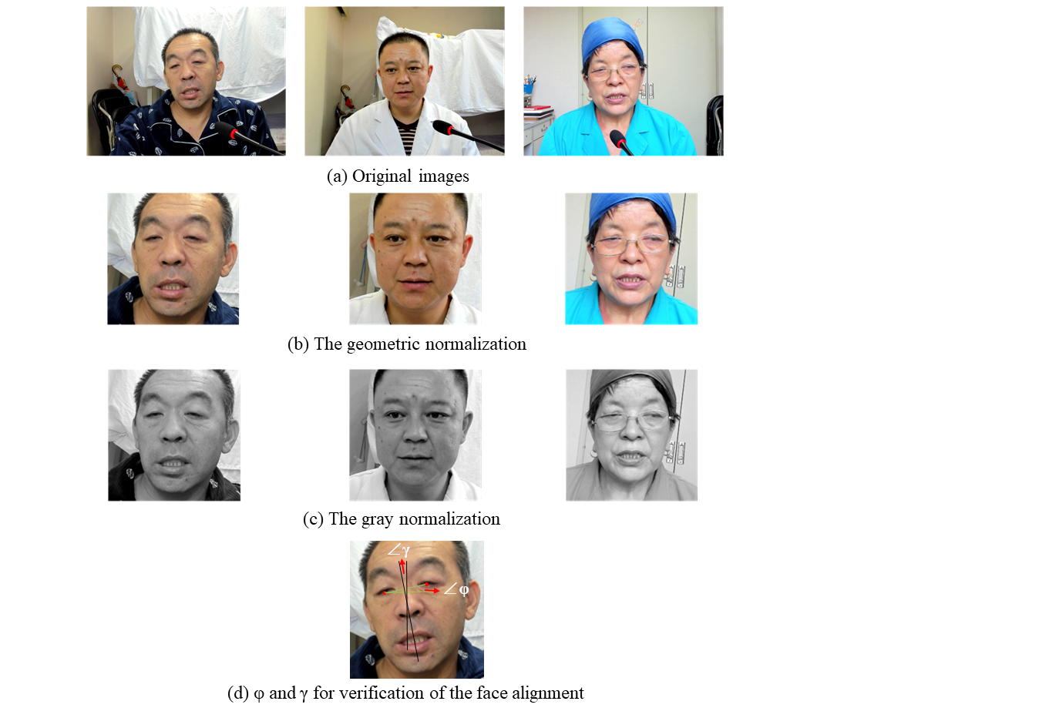

**Fig. 3** The result of the face alignment. $φ$ represents the angle between the center line of the eyes and the horizontal plane; $γ$ represents the angle between the sagittal plane and the bridge of the nose.

**Lip information extraction:** Based on 20 lip feature points, the left lateral lip angle , the right lateral lip angle , the distance of the lateral lip  and the distance of the internal lip  recalculated on each frame of the video inspired by [46]. Fig. 4 illustrates the face detection feature points, lip angles and distances calculated in this study. The example of the trajectories of lip angles and distances over time when speaking syllable /ma1/ is showed in Fig A. 2.

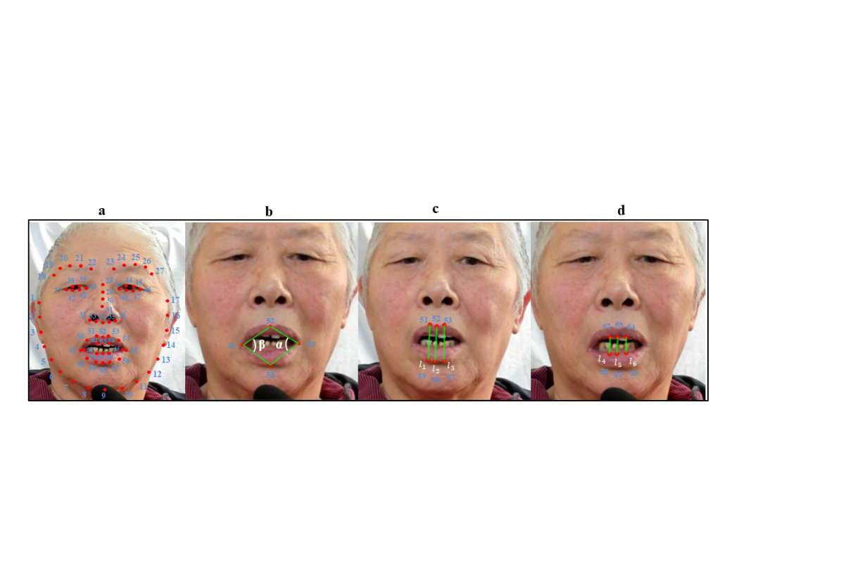

**Fig. 4** Face detection, angles and distances of lip. (a) 68 facial landmarks; (b) left and right lateral lip angles; (c) the lateral lip; (d) the internal lip.

**Outlier Detection:** there may be outliers when calculating the variation of lip movement trajectory in the time dimension. Based on the k-nearest neighborhood method [50], a point $m_{i}$ is defined as an outlier, when

$\left|m_{i}-\overline{m}\right|>ρσ$ (1)

where $\overline{m}$ is the mean value of k-nearest neighbor of $m_{i}$, $ρ$ is a constant and $σ$ is the variance about these k-nearest neighbor. In this study, the value of $ρ$ set 5 and replace $m_{i}$ with $\overline{m}$ for outlier correction. When the number of consecutive outliers is greater than 12, it is considered that the video file can be discarded. Fig A. 3 shows the result of the detection and correction of the outer lip movement. According to the statistics in our preliminary experiments, about 5% video record files could be discarded, which guarantees the video data are accurately recorded for the most part.

**2.4. Audio-video** [**synchronization**](javascript:;) **calibration**

Previous studies found that the movement of the speech articulators preceded the arrival of sound for about several hundred milliseconds, despite phonation and articulation should be in phase [51]. This phenomenon was often perceived as an asynchrony of visual and acoustic signals [52]. In the present study, an Articulatory Initiation Time (AIT) was defined as the interval stage between the start of the articulatory movement and the onset of vocal cord vibration to make real sound (see Fig 5). Such AIT should be considered in audio-video [synchronization](javascript:;), with an AIT of 600 ms reserved for dysarthric and healthy individuals was used to convert video frames before segmentation by re-positioning video data and audio transcribed with TextGrid. Furthermore, the articulators' static stage was defined as the time frames at an additional 400 ms before the AIT stage, and a final stage was defined as the 300 ms after the end of speech sound. Finally, manual inspection was carried out to ensure no apparent asynchrony in the multimodal data segments.

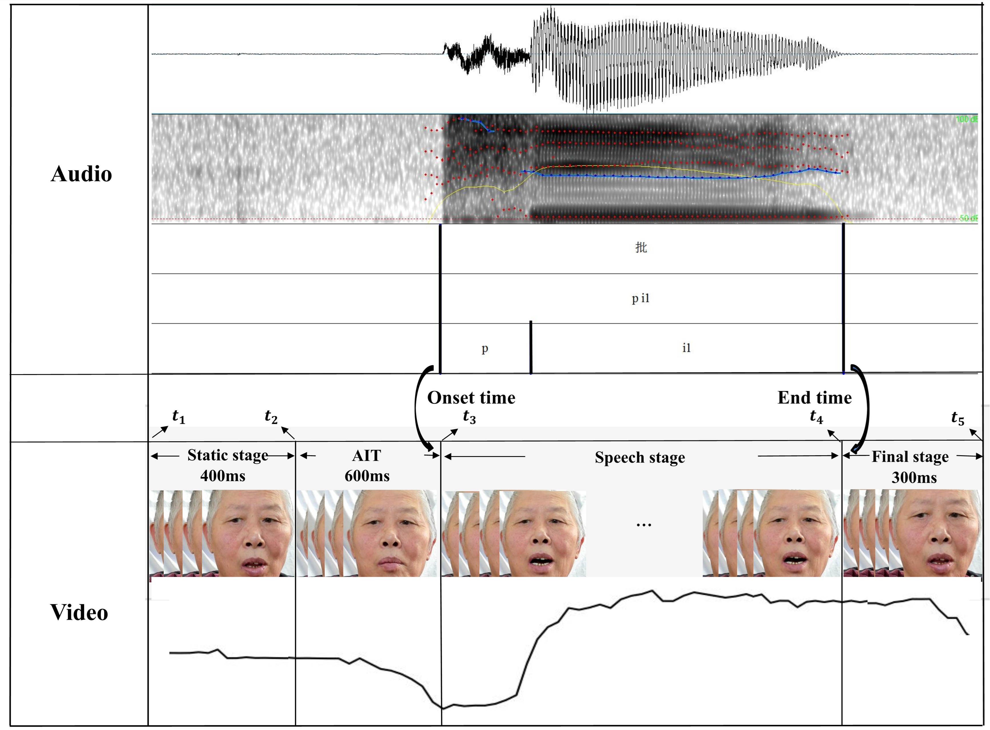

**Fig. 5** Schematic diagram of Audio-video [synchronization](javascript:;) calibration.

**2.5. Database description**

As shown in Table 2, the MSDM database contained 77.1 hours of synchronized audio and video data collected from 50 native Mandarin speakers (25 subacute stroke participants with dysarthria and 25 healthy controls). After removing the silence segments in the speech signals, 16.2 hours of speech data remain, including of 65,840 utterances files (25,800 syllables, 11,610 characters, 19,350 words, 9,030 sentences, and 50 spontaneous speech files).

The MSDM database not only included audio-video data but also contained the demographic characteristics (such as age, gender, and education level), cognitive ability evaluation results (such as MoCA and MMSE scores), comprehensive information on clinical speech assessments (such as NIHSS, BDAE, FDA) and lesion location reports of each participant. Detailed information on participants is provided in Table A. 1. All data reported in this paper, including audio-video and anonymized clinical data, will be available upon request.

**Table 2.** The description of content in current MSDM database.

|  |  |  |  |  |  |  |  |
| --- | --- | --- | --- | --- | --- | --- | --- |
|  | Syllable | Character | Word | Sentence | Spontaneous speech | Time  (hours) | Utterance time (hours) |
| Dysarthria  (number) | 10800 | 4860 | 8100 | 3780 | 25 | 32.3 | 6.8 |
| Normal  (number) | 15000 | 6750 | 11250 | 5250 | 25 | 44.8 | 9.4 |
| In total | 25800 | 11610 | 19350 | 9030 | 50 | 77.1 | 16.2 |
| Unit number  Mean (SD) | 2.10(0.41)  (1-3, phoneme) | 2.15(0.44)  (1-3, phoneme) | 2.19(0.44)  (2-4, character) | 4.88(1.91)  (3-11, character) | - | - | - |

**Captions:** Unit number means the numbers of each type of Chinese materials, for example, the mean number of phoneme in syllable or character, the mean number of characters in word or sentence, data presented as mean (standard deviation).

# 3. Preliminary Data Analysis

**3.1. Subset selection**

In order to determine the speech characteristics of dysarthria in the subacute phase of stroke, a subset that matched the demographic information was selected from the MSDM database, including 15 dysarthric patients and 16 healthy individuals. A total of 4,248 subjective correctly pronounced syllables from syllable and character tasks (Dysarthria: 1564 syllables, Normal: 2684 syllables), largely including all the Chinese monophthongs and consonants, were selected for the subsequent audio-video parameters analysis.

**Table 3.** Subjects with matched demographic information for further analysis (N = number of participants).

|  |  |  |  |  |
| --- | --- | --- | --- | --- |
|  | Dysarthria  N=15 | Normal  N=16 | Statistic | |
| Gender (Male:Female) | 13:2 | 13:3 | *χ2* = 0.16 | *p =* 0.68 |
| Age :mean(SD) | 59.0(11.3) | 53.1(7.9) | *t =* -1.69 | *p =* 0.12 |
| Education: mean(SD) | 13.9(3.1) | 10.9(2.9) | *t =* -2.74 | *p =* 0.07 |
| MoCA: mean(SD) | 21.7(3.6) | 28.6(2.8) | *t =* 5.27\* | *p =* 0.01 |

\*p < .05, \*\*p < .01

**3.2. Acoustic features extraction**

A fourteen-dimensional acoustic features set was extracted from several dimensions of speech: phonation, articulation, and prosody by using the scripts developed by the authors [18, 28, 42]. Acoustic analysis was carried out on the steady state medial 80% of vowel segment.

1. **Phonation:** Phonation deficits originates from abnormality in vocal fold vibration. It has been acoustically analyzed in terms of stability and noise-based features. For example, jitter and shimmer describe variations in fundamental period and amplitude of the voice signal, respectively [17]. The glottal-to-noise excitation ratio (GNE) and harmonics-to-noise ratio (HNR) features are introduced for their capability of measuring the degree of “noise” generated by the disorders. GNE quantifies the ratio of excitation due to vocal fold oscillations versus the excitation given by turbulent noise [53]. HNR measures the ratio of periodic and aperiodic signal energy. It can be seen as a signal-to-aspiration noise ratio when other aperiodicities in the signal are comparatively low [54]. Vocal fold excitation ratio (VFER) gives the amount of noise in terms of nonlinear energy and entropy value produced due to pathological vocal fold oscillation [55].
2. **Articulation:** Articulation deficits are mainly related to changes in position of tongue, lips, velum, and other articulators involved in speech production [17]. Articulation deficits have been studied via different acoustic features including tongue distance, jaw distance, movement degree (F2i/F2u ratio), VSA, FCR, VAI, and variability of F1 and F2. Variability of F1 and F2 associated with each vowel could be represented by the standard deviations of the F1 and F2 values, respectively [31]. Vowel space measurements are evaluated based on vowel formants, where jaw opening is thought to influence F1 values, and position of the tongue influences the F2 values, both of which can provide more objective information on formant distribution, including VSA, FCR, and VAI [29]. VSA is constructed by calculating the acoustic distance between F1 and F2, and the FCR and VAI were designed to measure vowel centralization [30]. The F2i/F2u ratio serves as a sensitive index of changes in the extent of articulatory movements and positions [56].
3. **Prosody:** Prosody is included to measure timing (rhythm and duration), intonation, and loudness during natural speech production, it manifests as mono loudness and changes in speech rate and pauses, including the vowel duration and loudness [17].

**3.3. Visual features extraction**

A set of ten-dimensional visual features was used to explore the deficits characteristics of lip movement in dysarthric patients compared with healthy controls during speech production. In the present study, these features are categorized into three types to reflect the articulation deficits of lip on amplitude, speed, and stability dimensions. Their definition and calculation are presented as follows:

1. **Amplitude**

**Minimum/maximum internal lip distance:** The minimum/maximum distance of the internal side of the lip in AIT and speech stages in Fig 5. **Minimum/maximum lip width:** the ratio of the minimum/maximum lip corner width in AIT and speech stages to the average lip width at four rest frames. Four rest frames were selected by using a sliding window (frame length = 4, frame shift = 1) during the static stage, and all four frames in the sliding window with the smallest standard deviation of the inner lip distance were taken as rest frames.

(2) **Speed**

**Velocity of the left/right lateral lip angle:** the slope of the minimum left/right lateral lip angle to the maximum left/right lateral lip angle in the AIT and speech stages. **Velocity of internal lip movement:** the slope of the minimum internal lip distance to the maximum internal lip distance in the AIT and speech stages.

(3) **Stability**

**Left/right lateral lip angle stability:** the mean of the variance of the left/right lateral lip angle for each sliding window during the 80% stable vowel segment. **Internal lip distance stability:** the mean of the variance of the internal lip distance in each sliding window during the 80% stable vowel segment. The frame length and frame shift of the sliding window are 6 and 1 respectively. The larger the value of these three features, the worse the stability of the lip movement.

A summary of the acoustic and visual kinematic features used in this study is shown in Table 4, where  and  represent the start of the AIT and the end of speech stage respectively, as shown in Fig 5.  represents the Euclidean Distance between face feature points 48 and 54, and is the average value of  in four rest frames.

**Table 4.** All the acoustic and visual kinematic features in current study.

|  |  |  |  |  |
| --- | --- | --- | --- | --- |
|  | Type | Features | Formula | Note |
| Acoustic features | Phonation | Jitter, Shimmer, Harmonics-to-noise ratio (HNR), Glottal-to-noise excitation ratio (GNE), Vocal fold excitation ratio (VFER) | [17, 53, 54, 55] |  |
| Articulation | Tongue distance, Jaw distance, Movement degree (F2i/F2u ratio), VSA, FCR, VAI, Variability of F1 and F2 | [17, 29, 30, 31, 56] |  |
| Prosody | Vowel duration and Loudness | [17] |  |
| Visual features | Amplitude | Minimum internal lip distance |  |  |
| Maximum internal lip distance |  |  |
| Minimum lip width |  |  |
| Maximum lip width |  |  |
| Speed | Velocity of the left lateral lip angle |  |  |
| Velocity of the right lateral lip angle |  |  |
| Velocity of internal lip movement |  |  |
| Stability | Left lateral lip angle stability |  | *T* represents an 80% stable vowel segment, *n* represents the number of sliding windows in time period *t.* |
| Right lateral lip angle stability |  |
| Internal lip distance stability |  |
| In total | 6 | 25 |  |  |

**3.4. Statistic analysis**

Statistical analyses were carried out on all acoustic and visual features. A linear mixed-effect regression model was applied for each feature to explore the factors related to speech performance, and to determine the differences in articulatory movement between subacute stroke patients with dysarthria and healthy individuals. Each linear-mixed effect regression model was constructed with fixed effects of group (dysarthria versus normal), cognitive level (MoCA scores), and age, and participants as random intercepts. The slope estimates, interpreted as the average effect of dysarthria or cognition, are presented as beta (B) with standard error (SE), where a positive value indicates an increase in such measure and a negative value indicates the opposite effect. Furthermore, in order to validate the effectiveness of the acoustic-visual feature set, the relationship between each acoustic or visual feature and the scores of FDA related categories (sum score of each category), such as the Articulation features (e.g., tongue distance, VSA, VAI) versus the scores of Tongue category (see Table A. 2) was examined. Specifically, correlation coefficients were computed between each objective acoustic-visual feature and subjective FDA scores of every category in all dysarthria patients. For all analyses, statistical significance alpha was set at 0.05. The models were developed using R and the lme4 package [57].

**3.5. Results**

Fig 6 illustrates the statistical results of acoustic features between dysarthric and healthy groups. The results of three type acoustic features are presented as follows: (1) Phonation: Jitter, Shimmer, and HNR of dysarthria patients were higher and more unstable than normal controls *(t = 3.51, p = .02; t = -8.92, p < .001; t = 3.74, p = .01)*. Meanwhile, GNE and VFER were slightly lower in patients *(t = -4.47, p < .001; t = 3.45, p = .02)*. (2) Articulation: The F2i/F2u ratio and VAI of normal group were significantly higher than dysarthria group *(t = 10.12, p < .001; t = 2.08, p = .03)*. Tongue distance and Jaw distance were smaller in patients during vowel production than normal subjects *(t = 12.50, p < .001; t = 10.95, p < .001)*. It can also be seen in Fig A. 4 that VSA of dysarthria patients was significantly smaller than normal group (*t* = -6.13, *p* < .001). FCR appeared to be higher in subacute stroke patients *(t = -4.92, p < .001)*. In addition, variability of formant can assess the relative acoustic stability in achieving vowel targets. It can be seen in Fig 6 that variability of F1 and F2 was significantly higher in dysarthria patients *(t = 2.32, p = .02; t = -5.58, p < .001)*. (3) Prosody: Vowel duration was significantly longer and more variable in dysarthria group than healthy controls *(t = 22.99, p < .001)*. The loudness of dysarthria group was a little lower than normal group *(t = -4.14, p = .01)*. The complete statistical values of acoustic features are presented in Table A. 6.

results_1

**Fig. 6** Comparison results of acoustic parameters between the dysarthria and normal groups, including the three types of acoustic features (\**p* < .05, \*\**p* < .01).

For visual kinematic features, the minimum internal lip distance of dysarthria patients was significantly bigger than healthy controls *(t = 2.05, p = .04)*. The maximum internal lip distance and lip width were slightly higher in dysarthria patients, though not statistically significant. The velocity of the right lateral lip angle of dysarthria patients was significantly higher than healthy controls *(t = 2.12, p = .03)*, and the velocity of the left lateral lip angle and internal lip movement were slightly higher in dysarthric patients. For Stability, there were significant differences in the stability of right and left lateral lip angle between dysarthria patients and healthy controls *(t = 5.31, p < .001; t = 3.24, p < .001)*. Although statistical significance was not present in internal lip distance stability, it was slightly higher in dysarthria patients. The subacute stroke patients with dysarthria showed less stability of lip movement during speech production. All statistical results associated with visual features are presented in Table A. 6.

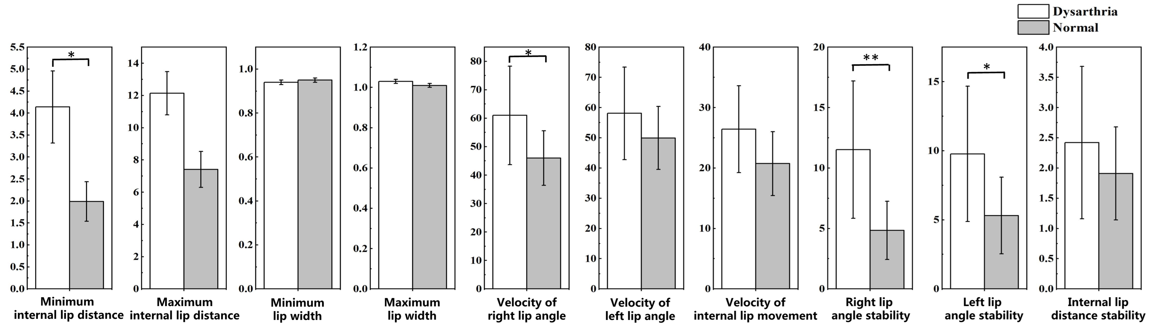

**Fig. 7** The statistical results of visual features between dysarthria and normal groups (\*p < .05, \*\*p < .01)

In addition, there were significant correlations among the objective acoustic-visual metrics and subjective FDA scores in dysarthria patients. Jitter was significantly correlated with the Velum and Laryngeal. Shimmer was significantly correlated with the Velum. Tongue distance and F2i/F2u ratio were significantly correlated with Reflex, Respiration, Lips, Jaw, and Intelligibility. Jaw distance was significantly correlated with Reflex, Respiration, Lips, Jaw, and Velum. Meanwhile, VSA and VAI were significantly correlated with Reflex, Respiration, Lips, Jaw, Tongue, and Intelligibility. FCR was significantly correlated with Reflex, Respiration, Lips, Jaw, Tongue, and Intelligibility. For prosody features, the correlations between vowel duration and all categories of FDA were significantly negatively, especially for Respiration, Lips, Laryngeal, Tongue, and Intelligibility. And Loudness was also negatively correlated with Respiration, Lips, Velum, Laryngeal, Tongue, and Intelligibility. Moreover, significant correlations were also found between visual features and FDA scores. Minimum and maximum internal lip distances were significantly correlated with all categories of FDA , such as Respiration, Lips, Tongue, and Intelligibility. For speed of lip movement, velocity of right, left, and internal lip angle were positively correlated with Reflex. Left and internal lip angle stability were significantly correlated with Reflex, Lips, Jaw, and Intelligibility. Right lip angle stability was significantly correlated with Reflex. All correlation results between acoustic-visual kinematic features and FDA scores are presented in Table 5.

**Table 5.**  The correlations between acoustic-visual features and FDA scores (eight categories).

|  |  |  |  |  |  |  |  |  |  |  |
| --- | --- | --- | --- | --- | --- | --- | --- | --- | --- | --- |
| r(p) | Type | Features | Reflex  (12) | Respiration (8) | Lips  (20) | Jaw  (8) | Velum  (12) | Laryngeal  (16) | Tongue  (24) | Intelligibility  (12) |
| Acoustic features | Phonation | Jitter | - | - | - | - | 0.24  (0.00) | 0.17  (0.00) | - | - |
| Shimmer | - | - | - | - | 0.17  (0.00) | - | - | - |
| Articulation | Tongue distance | 0.13  (0.00) | 0.17  (0.00) | 0.32  (0.00) | 0.23  (0.00) | - | - | - | 0.22  (0.00) |
| Jaw distance | 0.25  (0.00) | 0.20  (0.00) | 0.24  (0.00) | 0.31  (0.00) | 0.19  (0.00) | - | - | - |
| F2i/F2u ratio | 0.18  (0.00) | 0.26  (0.00) | 0.35  (0.00) | 0.32  (0.00) | - | - | - | 0.32  (0.00) |
| VSA | 0.24  (0.00) | 0.27  (0.00) | 0.36  (0.00) | 0.41  (0.00) | - | - | 0.20  (0.03) | 0.24  (0.00) |
| FCR | -0.15  (0.00) | -0.25  (0.00) | -0.38  (0.00) | -0.22  (0.00) | - | - | -0.20  (0.00) | -0.28  (0.00) |
| VAI | 0.22  (0.00) | 0.31  (0.00) | 0.42  (0.00) | 0.30  (0.00) | - | 0.15  (0.00) | 0.22  (0.00) | 0.34  (0.00) |
| Prosody | Vowel duration | -0.24  (0.00) | -0.48  (0.00) | -0.51  (0.00) | -0.31  (0.00) | -0.44  (0.00) | -0.48  (0.00) | -0.48  (0.00) | -0.46  (0.00) |
| Loudness | - | -0.24  (0.00) | -0.19  (0.00) | - | -0.41  (0.00) | -0.30  (0.00) | -0.30  (0.00) | -0.28  (0.00) |
| Visual features | Amplitude | Minimum internal lip distance | -0.24  (0.00) | -0.42  (0.00) | -0.33  (0.00) | -0.36  (0.00) | -0.24  (0.00) | -0.40  (0.00) | -0.44  (0.00) | -0.40  (0.00) |
| Maximum internal lip distance | - | -0.34  (0.00) | -0.23  (0.00) | -0.22  (0.00) | -0.24  (0.00) | -0.35  (0.00) | -0.38  (0.00) | -0.31  (0.00) |
| Minimum lip width | -0.18  (0.00) | -0.11  (0.00) | -0.12  (0.00) | -0.12  (0.00) | - | -0.12  (0.00) | -0.12  (0.00) | -0.12  (0.00) |
| Maximum lip width | - | - | - | - | -0.15  (0.00) | - | - | - |
| Speed | Velocity of the right lip angle | 0.13  (0.01) | - | - | - | - | - | - | - |
| Velocity of the left lip angle | 0.10  (0.00) | - | - | - | - | - | - | - |
| Velocity of internal lip movement | 0.08  (0.00) | - | - | - | - | - | - | - |
| Stability | Right lip angle stability | 0.08  (0.00) | - | - | - | - | - | - | - |
| Left lip angle stability | 0.09  (0.00) | - | 0.07  (0.00) | 0.08  (0.00) | - | - | - | 0.09  (0.00) |
| Internal lip distance stability | 0.09  (0.00) | - | 0.08  (0.00) | 0.07  (0.00) | - | - | - | 0.07  (0.00) |

**Captions:** the full score for each category is given in the parentheses, data presented as r(p).

# 4. Discussion

Objective measurements of speech have been widely adopted as an effective complementary tool to clinical assessment of speech. It has well been documented that, early and accurate diagnosis and intervention to speech disorders of neurological etiologies are desirable, which warrant better therapeutic outcomes, especially with the help of using acoustic and kinematics features of speech as potential diagnostic biomarkers [34, 35]. Despite the advances in technologies, effective and objective diagnosis and evaluation still see some challenges, including issues related to small data samples [24], similarity and simple material [25], and the performance of previous systems would be decreased when used to assess speech from severe patients [58]. Such a robust system should perfectly handle speech variability caused by any of the possible characteristic expressions of dysarthria, especially for the group of subacute stroke patients.

This request motivated us to establish a standard, adequately labelled training database of dysarthric speech for clinical and research needs. The first part of the study was to establish an audio-visual integrated speech database associated with subacute stroke patients with dysarthria. In comparison to other existing dysarthria datasets, the current MSDM database has been expanded and improved in the following aspects: size and content. Dysarthric data has usually involved fewer than five participants. For example, Hasegawa-Johnson et al. [69] studied the speech performance of three talkers with spastic dysarthria caused by cerebral palsy, and the Whitaker database was created with the speech data obtained from only six dysarthria patients [24]. Given the scarcity and difficulty associated with data collection from subacute stroke patients, there is no dysarthria database aiming for the particular stage of this disease. Furthermore, speech materials of existing datasets contained either sustained vowel production or a small number of words and short phrases. They apparently lacked diversity in form and content. For example, the Nemours database consists of short nonsense sentences and sentences spoken by eleven male dysarthria speakers [25]. In the MSDM database, all Mandarin pronunciation data (e.g., syllable, character, word, sentence, spontaneous speech) has been provided for serving important functions in different research purposes, such as the cross-language researches. In addition to audio data, we have synchronized recorded video data, which can provide valuable orofacial visual information for speech perception. Until to now, only the UA-Speech dataset [26] includes visual information of nineteen speakers with cerebral palsy to develop assistive automatic ASR technology for people with motor disabilities. Given the limited translation of the existing research to the subjective clinical assessments and the limitations of the objective analysis of dysarthria in the telemodality, it is essential to progress the remote monitoring of dysarthria with different diseases by using convenient and cost-effective technology, such as visual information [70]. Moreover, to improve the performance of objective assessment, the MSDM database included complete clinical assessments (e.g., FDA, MoCA, BDAE, MMSE) and personal information (e.g., age, gender, and education years) associated with the audio-video data obtained. Combining subjective and objective information allowed a better understanding of the deficits in the central nervous system (CNS) with the abnormal articulatory movement in dysarthria [13, 28]. In conclusion, this large-scale and comprehensive training database may be the key to improve the early objective detection and classification of dysarthric speech and boost the performance of automatic assessment of speech intelligibility associated with dysarthric speech, as variability embedded in speech can be better handled with more training data [23]. The comparison table of existing dysarthric databases and the current MSDM database has been provided in Table A.7.

Based on the established MSDM database, the present study also revealed the particular speech characteristics of dysarthria patients at the subacute stage by combining phonological and kinematic analyses. As a result, pathological speech of subacute stroke patients with dysarthria showed the following characteristics regarding different acoustic features: (1) Phonation: The acoustic features related to voice quality in subacute stroke patients, such as jitter, shimmer, HNR, and GNE, were significantly larger than normal controls. Meanwhile, there were significant correlations positively among these features and Velum, Laryngeal of FDA assessment, which might suggest that the voice quality was influenced by the disturbance impairment of laryngeal muscle activity. These results are consistent with findings reported in previous studies based on English-speaking patients with stroke [71]. In addition, the worsened voice quality was also found in other types of dysarthria [72, 73, 74]. For example, Sapir et al. [66] reported voice tremor, breathy, harsh, or hoarse voice quality, sometimes accompanied by decay in vocal loudness when evaluating the voices associated with dysarthria on vowel articulation in idiopathic Parkinson’s disease. These findings implied that dysphonia especially hoarseness might be a common characteristic in dysarthric speech, regardless of lesion site [75, 76]. (2) Articulation: Some studies revealed vowel centralization and a reduced vowel space as typical characteristics in vowel production among dysarthric patients [29]. Nevertheless, a reduced range of articulatory movement to the extent that the intended tongue location and degree of vocal tract constriction were not fully achieved. Wong et al. [63] reported that PD individuals showed greater tongue kinematic parameters during habitual and loud sentence productions. Similarly, in the present study, the parameters related to articulatory movements suggested that dysarthria patients caused by stroke exhibited a smaller and more concentrated vowel space. These articulation features were also significantly correlated with Reflex, Respiration, Lips, Jaw, Tongue, and Intelligibility. This is similar to the findings reported in previous studies of Mandarin-speaking individuals during stroke recovery period [77]. Vowel space area reflects gross motor control of articulators. It follows that, the present results implied that subacute stroke patients with dysarthria might have imprecise, diverse articulatory configurations compared to healthy adults. Most dysarthric patients in the preliminary study had lesions in the basal [ganglia](javascript:;) and cerebellum (See Table A.1). Recent studies documented that the cerebellum and the basal ganglia were reciprocally interconnected with speech production [77]. In the DIVA model [79], [basal](javascript:;) [ganglia](javascript:;) is believed to contribute to gating motor commands, and the role of the basal ganglia is not only in the initiation but also in the selection of actions by the suppression of the competing ones [80]. On the other hand, the cerebellum is not only involved in representing the feedforward motor programs to map the speech sound to the articulator velocity [79] and also contributes to the mapping between sensory states and the feedback motor command [61]. The lesions of the cerebellum and the basal ganglia may reveal the mismatch between expected and actual movement that caused imprecise articulatory configurations during speech production. (3) Prosody: Not unexpectedly, vowel duration was significantly longer and more variable in the dysarthria group than in healthy controls. Previous results also found a weakened sequence length effect in speakers with dysarthria caused by strokes, and the study did not demonstrate this pattern with Parkinson's disease and control participants [61]. The correlation results with FDA assessment also supported the hypothesis that the dysprosody of dysarthria patients caused by the cerebellum and basal ganglia strokes possibly due to overall deficits of the cerebellar and basal ganglia thalamo-cortical network [78].

In addition to acoustical features, visual kinematic data also revealed that subacute stroke patients have deficits in their lip kinematics during speech production. The amplitude of lip movement is slightly higher than the health controls, but the speech duration is significantly longer, and the stability is significantly worse than normal controls. The findings suggested that the clinical features of dysarthria caused by the cerebellum and basal ganglia strokes, including vowel imprecision, are not the outcome of restrictions in the range of movement of the muscles of the articulators but the imprecise position and control of movement trajectories in individuals with strokes [65]. Results of amplitude and speed of articulatory movement may be a result of over-compensation by the subacute stroke patients. They are unable to execute well-controlled movements required for speech due to poor control over the lip or tongue movement [64]. The same phenomenon was also discovered in dysarthria caused by other neurology disorders [67, 81]. For example, Goozee et al. [67] examined the complex interactions between the different kinematic parameters recorded from traumatic brain injury (TBI) participants. They revealed a disturbance in the “control” of tongue speed rather than a disturbance in speed. The significant correlations between left/internal lip angle stability and Reflex, Lips, Jaw, and Intelligibility of subjective FDA scores also proved that the deviant speech features in subacute stroke patients are associated with imprecise muscle control ability*.* In conclusion, these acoustic-visual features were significantly different between the dysarthria patients and normal controls, and correlated with the FDA assessment results, implying that the dysarthric speech of the patients with cerebellum and basal ganglia strokes might cause the mismatch in predicting articulatory movements and wrong sensory state feedback not to hypokinetic dysarthria.

Furthermore, the present study also considered other factors that could influence dysarthria in addition to stroke, such as cognitive decline. To explore the potential influence of cognitive impairment on speech production, the cognitive ability (MoCA scores) also has been considered as a influence factor for statistical analysis. In the end, it was found that part of the results of cognitive level had consistency with the differences between dysarthria and healthy groups by comparing the effects of speech [quality](javascript:;) and articulatory movement. But the degree of influence from stroke and cognition were different, such as the loudness and vowel duration. This perhaps is the reason that acoustic measurements are inconsistent across different dysarthria studies and it needs to be addressed by further classifying different subtypes of dysarthria after stroke. Detailed results of statistical analyses for all acoustic and visual parameters are presented in Tables A. 6.

While the present study provided a promising database and results in the dysarthric speech of sub-stroke patients, several limitations are observed. First, different types of dysarthria were identified, and each type showed different and unique abnormal speech characteristics [1]. The present study did not attempt to classify dysarthric speech according to these classifications as it only revealed the differences in speech quality and articulatory movement associated with subacute stroke patients most lesioned on the cerebellum and basal ganglia compared with healthy participants. It is still unclear whether these results would be consistent after patients are classified into different subtypes of dysarthria. Next, further inspection of the speech performances of different subtypes is promising to base the results of FDA scores in our database. Besides, several studies found that different brain lesion directly related to the characteristics of speech impairment. For example, ataxic dysarthria was mainly caused by cerebellar dysfunction (e.g., cerebellar stroke) [61]. In the current MSDM database, the lesion sites of 25 subacute stroke patients were mainly distributed in the cerebellum, [basal](javascript:;) [ganglia](javascript:;), and [pons](javascript:;). It is still uncertain how and why these locations or circuits damage could cause other abnormal speech performance in subacute stroke patients. The functional network and direct evidence of pathologic speech are still lacking. In the future, it was intend to further explore the neural mechanisms of dysarthric speech by combining the lesion site information.

# 5. Conclusion

The current is a pioneering study establishing a comprehensive MSDM database of Chinese healthy and dysarthric speech data. In addition, analyses of synchronized audio-video data provided a detailed description and understanding of how speech production was affected by subacute stroke. The subacute stroke patients with dysarthria showed abnormalities in vowel production, as revealed by the array of acoustic measures, including aberrant speech duration and failure to reach canonical formant frequencies resulting in compressed or reduced working vowel space, crowdedness and poor stability of vowels. Moreover, the stability of lip movement significantly decreased, the amplitude and speed increased slightly were shown in the kinematic analysis. The high correlations between the objective acoustic-kinematic parameters and subjective assessment were also found. Results of the present study are valuable for exploring of noninvasive speech biomarkers to lead to early and accurate diagnosis of various types of dysarthria.

# Acknowledgements

This work was supported in part by the National Key R&D Program of China (2020YFC2004100), National Natural Science Foundation of China (NSFC U1736202, NSFC 61771461), Shenzhen Peacock Team Project (Grant No. KQTD20200820113106007) and Shenzhen Science and Technology Program (Grant No. JCYJ20210324115810030)

# References

[1]M. Nicholas, Aphasia and dysarthria after stroke, in M. P. Barnes, B. H. Dobkin, J. Bogousslavsky (Eds.), Recovery after Stroke, American Stroke Association, New York, 2005, pp. 474-502.

[2]H. Kim, M. Hasegawa-Johnson, A. Perlman, Vowel contrast and speech intelligibility in dysarthria, Folia Phoniatr. Logo. 63(4) (2011) 187-194.

[3]C. Mitchell, A. Bowen, S. Tyson, Z. Butterfint, P. Conroy, Interventions for dysarthria due to stroke and other adult-acquired, non-progressive brain injury, Cochrane Database Syst. Rev. 1 (1) (2017) CD002088.

[4]K.M. Yorkston, Treatment efficacy: dysarthria, J. Speech Lang. Hear. Res. 39 (5) (1996) S46-S57.

[5]E. Kumral, B. Özkaya, A. Sagduyu, H. Şirin, E. Vardarli, M. Pehlivan, The ege stroke registry: A hospital-based study in the Aegean region, Izmir, Turkey, Cerebrovasc. Dis. 8 (5) (1998) 278-288.

[6]M. Ali, P. Lyden, M. Brady, Aphasia and dysarthria in acute stroke: Recovery and functional outcome, Int. J. Stroke 10 (3) (2015) 400-406.

[7]W. Wang, B. Jiang, H. Sun, X. Ru, D. Sun, L. Wang, V. L. Feigin, Prevalence, incidence, and mortality of stroke in China: results from a nationwide population-based survey of 480 687 adults, Circulation 135(8) (2017) 759-771.

[8]L. D. Wang, J. M. Liu, Y. Yang, B. Peng, Y. L. Wang, Stroke prevention and treatment in my country is still facing great challenges: Summary of China Stroke Prevention and Control Report 2018, Chin. J. Cir. (02) (2019) 105-119.

[9]M.C. Brady, A.M. Clark, S. Dickson, G. Paton, R.S. Barbour, The impact of stroke-related dysarthria on social participation and implications for rehabilitation, Disabil. Rehabil. 33 (3) (2011) 178-186.

[10]N. Miller, S. Bloch, A survey of speech–language therapy provision for people with post-stroke dysarthria in the UK, Int. J. lang. Commun. Disord. 52 (6) (2017) 800-815.

[11]A. Ghio, L. Giusti, E. Blanc, S. Pinto, French adaptation of the “Frenchay Dysarthria Assessment 2” speech intelligibility test, Eur. Ann. Otorhinolary. Head Neck Dis. 137 (2) (2020) 111-116.

[12]E.C. Guerra, D.F. Lovey, A modern approach to dysarthria classification, in Proceedings of the 25th Annual International Conference of the IEEE Engineering in Medicine and Biology Society, IEEE 3 (2003) 2257-2260.

[13]B.E. Murdoch, Dysarthria: A physiological approach to assessment and treatment, Nelson Thornes, Oxford, 1998.

[14]M.S. Paja, T.H. Falk, Automated dysarthria severity classification for improved objective intelligibility assessment of spastic dysarthric speech, in Thirteenth Annual Conference of the International Speech Communication Association, 2012.

[15]C. Mitchell, A. Bowen, S. Tyson, Z. Butterfifint, P. Conroy, Interventions for dysarthria due to stroke and other adult-acquired, non-progressive brain injury, Cochrane Database Syst. Rev. 1(1) (2017) Cd002088.

[16]P.C. Doyle, H.A. Leeper, Dysarthric speech: a comparison of computerized speech recognition and listener intelligibility, J. Rehabil. Res. Dev. 34(3) (1997) 309-316.

[17]A. Hernandez, E.J. Yeo, S. Kim, M. Chung, Dysarthria Detection And Severity Assessment Using Rhythm-Based Metrics, in Interspeech, ISCA, London, 2020, pp. 2897-2901.

[18]J.C. Vásquez-Correa, J.R. Orozco-Arroyave, T. Bocklet, E. Nöth, Towards an automatic evaluation of the dysarthria level of patients with Parkinson's disease, J. Commun. Disord. 76 (2018) 21-36.

[19]B. Walsh, A. Smith, Basic parameters of articulatory movements and acoustics in individuals with Parkinson’s disease, Movement Disord. 27 (7) (2012) 843-850.

[20]P P. Urban, S. Wicht, G. Vukurevic, Dysarthria in acute ischemic stroke: lesion topography, clinicoradiologic correlation, and etiology, Neurology, 56 (8) (2001) 1021-1027.

[21]E. Koyuncu, P. Çam, N. Altınok, D.E. Çallı, T.Y. Duman, N. Özgirgin, Speech and language therapy for aphasia following subacute stroke, Neural Regen. Res. 11 (10) (2016) 1591.

[22]E. Godecke, K. Hird, E.E. Lalor, T. Rai, M.R. Phillips, Very early poststroke aphasia therapy: A pilot randomized controlled efficacy trial, Int. J. Stroke 7 (2012) 635-644.

[23]T. Wang, Q. Yan, J. Pan, F. Zhu, R. Su, Y. Guo, N. Yan, Towards the speech features of early-stage dementia: design and application of the mandarin elderly cognitive speech database, in Interspeech, 2019, pp. 4529-4533.

[24]B. MacWhinney, D. Fromm, M. Forbes, A. Holland, Aphasia bank: Methods for studying discourse, Aphasiology 25 (11) (2011) 1286-1307.

[24]J.R. Deller, M.S. Liu, L.J. Ferrier, P. Robichaud, The Whitaker database of dysarthric (cerebral palsy) speech, J. Acoust. Soc. Am. 93(6) (1993) 3516-3518.

[25]X. Menendez-Pidal, J.B. Polikoff, S.M. Peters, J.E. Leonzio, H.T. Bunnell, The Nemours database of dysarthric speech, in Proceeding of Fourth International Conference on Spoken Language Processing. ICSLP'96, IEEE 3 (1996) 1962-1965.

[26]H. Kim, M. Hasegawa-Johnson, A. Perlman, J. Gunderson, T.S. Huang, K. Watkin, S. Frame, Dysarthric speech database for universal access research, in Ninth Annual Conference of the International Speech Communication Association, 2008.

[27]F. Rudzicz, A.K. Namasivayam, T. Wolff, The TORGO database of acoustic and articulatory speech from speakers with dysarthria, Lang. Resour. Eval. 46 (4) (2012) 523-541.

[28]G. Noffs, T. Perera, S.C. Kolbe, C.J. Shanahan, F.M. Boonstra, A. Evans, A.P. Vogel, What speech can tell us: A systematic review of dysarthria characteristics in Multiple Sclerosis, Autoimm. Rev. 17(12) (2018) 1202-1209.

[29]M.W. Caverlé, A.P. Vogel, Stability, reliability, and sensitivity of acoustic measures of vowel space: A comparison of vowel space area, formant centralization ratio, and vowel articulation index, J. Acoust. Soc. Am. 148 (3) (2020) 1436-1444.

[30]S. Sapir, L.O. Ramig, J.L. Spielman, C. Fox, Formant centralization ratio: A proposal for a new acoustic measure of dysarthric speech, J. Speech Lang. Hear. Res. 53 (1) (2010) 114-125.

[31]R. Banks, M.K. Arjmandi, H. Ghasemzadeh, M. Berardi, Formant dynamics in vowel pronunciation as acoustic correlates of concussed speech, Brain Injury 33 (2019) 2-3.

[32]M.K. Arjmandi, M. Pooyan, An optimum algorithm in pathological voice quality assessment using wavelet-packet-based features, linear discriminant analysis and support vector machine, Biomed. Signal Process. Cont. 7 (1) (2012) 3-19.

[33]H. Ghasemzadeh, M.K. Arjmandi, Toward optimum quantification of pathology-induced noises: An investigation of information missed by human auditory system. IEEE Trans. Audio Speech Language Process. 28 (2019) 519-528.

[34]J.A. Whitfield, C. Dromey, P. Palmer, Examining acoustic and kinematic measures of articulatory working space: Effects of speech intensity, J. Speech Lang. Hea. Res. 61(5) (2018) 1104-1117.

[35]A. Gómez, A. Tsanas, P. Gómez, D. Palacios-Alonso, V. Rodellar, A. Álvarez, Acoustic to kinematic projection in Parkinson's disease dysarthria, Biomed. Signal Process. Cont. 66 (2021) 102422.

[36]L. Velayudhan, S.H. Ryu, M. Raczek, M. Philpot, J. Lindesay, M. Critchfield, G. Livingston, Review of brief cognitive tests for patients with suspected dementia, Int. Psychogeriatr. 26 (8) (2014) 1247-1262.

[37]K.K. Tsoi, J.Y. Chan, H.W. Hirai, S.Y. Wong, T.C. Kwok, Cognitive tests to detect dementia: a systematic review and meta-analysis, JAMA Int. Med. 175 (9) (2015) 1450-1458.

[38]P. Enderby, Frenchay dysarthria assessment, Brit. J. Disord. Commun. 15(3) (1980) 165-173.

[39]Zhang, Q. L. (1996). Modern rehabilitation of speech and language disorders (lecture). Chin. Rehabilitation (2)：87-90.

[40]Feng, X.H, Qiu, W. H., Chen, Z. C., Wu, H. X., Qin, X. Y. (2019). The kinematic characteristics of articulatory articulation in patients with motor dysarthria: a study based on electromagnetic articulatory actigraph. Chinese Rehabilitation Theory and Practice (2): 125-134 .

[41]G.A. Ortiz, R.L. Sacco, National institutes of health stroke scale (nihss), Wiley Encyclopedia of Clinical Trials, New York, 2007.

[42]P. Boersma, D. Weenink, Praat, a system for doing phonetics by computer, Glot Int. 5 (2001) 341-345.

[43]T. Wang, C. Lian, J. Pan, Q. Yan, F. Zhu, M.L. Ng, N. Yan, Towards the speech features of mild cognitive impairment: Universal evidence from structured and unstructured connected speech of Chinese, in Interspeech, 2019, pp. 3880-3884.

[44]X He, X. L. Wang, X. Z. Zhou, A Syllable Separation Method in Chinese Speech Recognition, Fire Comm. Contr. 29(6) (2004) 94-96.

[45]J. Yang, Z. P. Li, P. Su, Review of speech segmentation and endpoint detection studies,Comp.Appl. (01) (2000) 1-7.

[46]D. Jiang, G. Lv, I. Ravyse, X. Jiang, Y. Zhang, H. Sahli, R. Zhao, Audio visual speech recognition and segmentation based on dbn models, in: M. Grimm, K. Kroschel (Eds.), Robust Speech Recognition and Understanding, I-Tech, Vienna, 2007, pp. 139.

[47]V. Kazemi, J. Sullivan, One millisecond face alignment with an ensemble of regression trees, in Proceedings of the IEEE conference on computer vision and pattern recognition, IEEE, 2014, pp. 1867-1874.

[48]K.T. Talele, S. Kadam, Face detection and geometric face normalization, in TENCON 2009-2009 IEEE Region 10 Conference, IEEE, 2009, pp. 1-6.

[49]G. Li, X. Cai, X. Li, Y. Liu, An efficient face normalization algorithm based on eyes detection, in 2006 IEEE/RSJ International Conference on Intelligent Robots and Systems, IEEE, 2006, pp. 3843-3848.

[50]S. Basu, M. Meckesheimer, Automatic outlier detection for time series: an application to sensor data, Knowl. Inform. Syst. 11(2) (2007) 137-154.

[51]P. Auzou, C. Ozsancak, R.J. Morris, M. Jan, F. Eustache, D. Hannequin, Voice onset time in aphasia, apraxia of speech and dysarthria: a review, Clin. Linguist. Phonet. 14(2) (2000) 131-150.

[52]L. Terry, Audio-visual asynchrony modeling and analysis for speech alignment and recognition, Doctoral dissertation, Northwestern University, 2011.

[53]J. I. Godino-Llorente, V. Osma-Ruiz, N. Saenz-Lechon, P. Gomez-Vilda, M. Blanco-Velasco, F. Cruz-Roldan, The effectiveness of the glottal to noise excitation ratio for the screening of voice disorders, J. Voice 24 (2010) 47-56.

[54]P. J. Murphy, O. O. Akande, Noise estimation in voice signals using short-term cepstral analysis, J. Acoust. Soc. Am. 121(3) (2007) 1679-1690.

[55] B. Karan, S.S. Sahu, K. Mahto, Parkinson disease prediction using intrinsic mode function based features from speech signal. Biocybernet. Biomed. Eng. 40(1) (2020) 249-264.

[56]G. Shengnan, W. Yongli, Y. Minmin, W. Qin, Q. Hong, H. Zhaoming, Relationship between vowel production and speech clarity in post-stroke dysarthria patients, Chin. J. Rehabil. Theor. Pract. Jan. 27(1) (2021) 43-47.

[57]D. Bates, M. Maechler, and B. Bolker, "lme4: Linear mixedeffects models using S4 classes," R package version: 0.999375- 38 ed, 2011

[58]V.Y. Mhsc, A. Mihailidis, Difficulties in automatic speech recognition of dysarthric speakers and implications for speech-based applications used by the elderly: a literature review, Assist. Technol. Official J. Resna 22(2) (2010) 99-112.

[59]R.D. Kent, G. Weismer, J.F. Kent, H.K. Vorperian, J.R. Duffy, Acoustic studies of dysarthric speech: Methods, progress, and potential, J. Commun. Disord. 32 (3) (1999) 141-186.

[60]H. Kim, M. Hasegawa-Johnson, A. Perlman, Vowel contrast and speech intelligibility in dysarthria, Folia Phoniatr. Logop. 63(4) (2011) 187-194.

[61]K. A. Spencer, D. L. Slocomb, The neural basis of ataxic dysarthria, Cerebellum 6(1) (2007) 58-65.

[62]H. Zhang, N. Yan, L. Wang, M.L. Ng, Energy distribution analysis and nonlinear dynamical analysis of phonation in patients with Parkinson's disease, in 2017 Asia-Pacific Signal and Information Processing Association Annual Summit and Conference, Piscataway: IEEE, 2017, pp. 630-635.

[63] M.N. Wong, M. Kuruvilla-Dugdale, M.L. Ng, Differential effects of increased loudness on tongue kinematics in individuals with PD? Analyses of two cases, Speech Lang. Hear. Res. 20(1) (2017) 49-56.

[64] J.V. Goozée, A.K. Shun, B.E. Murdoch, Effects of increased loudness on tongue movements during speech in nondysarthric speakers with Parkinson’s disease, J. Med. Speech Lang. Pathol. 19(1) (2011) 42–53.

[65] M.N. Wong, B.E. Murdoch, B.M. Whelan, Lingual kinematics during rapid syllable repetition in Parkinson's disease, Int. J. Lang. Commun. Dis. 47(5) (2012) 578-588.

[66]S. Sapir, J. L. Spielman, L. O. Ramig, B. H. Story, C. Fox, Effects of intensive voice treatment (the Lee Silverman Voice Treatment [LSVT]) on vowel articulation in dysarthric individuals with idiopathic Parkinson disease: acoustic and perceptual findings, J. Speech Lang. Hear Res. 50(4) (2007) 899-912.

[67]J. V. Goozee, B. E. Murdoch, D. G. Theodoros, Kinematic analysis of tongue movements in dysarthria following traumatic brain injury using electromagnetic articulography, J. Brain Injury. 14(2) 2000 153-174.

[68]D.E. King, Dlib-ml: A machine learning toolkit, J. Mach. Learn. Res. 10 (2009) 1755-1758.

[69]M. Hasegawa-Johnson, J. Gunderson, A. Perlman, T. Huang, HMM-based and SVM-based recognition of the speech of talkers with spastic dysarthria, in 2006 IEEE International Conference on Acoustics Speech and Signal Processing Proceedings, IEEE (2006) 1060-1063.

[70]J.S. Sevitz, B.R. Kiefer, J.E. Huber, M.S. Troche, Obtaining objective clinical measures during telehealth evaluations of dysarthria, Am. J. Speech Lang. Pathol. 30(2) (2021) 503-516.

[71]C. Mackenzie, Dysarthria in stroke: a narrative review of its description and the outcome of intervention, Am. J. Speech-Lang. Pathol. 13(2) (2011) 125-13

[72]R. Chiaramonte, M. Vecchio, A systematic review of measures of dysarthria severity in stroke patients, PM&R, 13(3) (2021) 314-324.

[73]J. Lee J, K.C. Hustad, G. Weismer, Predicting speech intelligibility with a multiple speech subsystems approach in children with cerebral palsy, J. Speech Lang. Hear. Res. 57(5) (2014) 1666-1678.

[74]K. Dashtipour, A. Tafreshi, J. Lee, B. Crawley, Speech disorders in Parkinson's disease: pathophysiology, medical management and surgical approaches, Neurodegener. Dis. Man. 8(5) (2018) 337-348.

[75]C. Mackenzie, Dysarthria in stroke: a narrative review of its description and the outcome of intervention, Int. J. Speech Lang. Pathol. 13(2) (2011) 125-136.

[76]Y. Kim, R.D. Kent, G. Weismer, An acoustic study of the relationships among neurologic disease, dysarthria type, and severity of dysarthria, J. Speech Lang. Hear. Res. 54 (2011) 417-429.

[77]Z. Mou, Z. Chen, J. Yang, L. Xu, Acoustic properties of vowel production in Mandarin-speaking patients with post-stroke dysarthria, Sci. Rep. 8 (2018) 14188.

[78]M.C.Silveri, Contribution of the cerebellum and the basal ganglia to language production: speech, word fluency, and sentence construction-evidence from pathology, Cerebellum 20(2) (2021) 282-294.

[79]F.H. Guenther, T. Vladusich, A neural theory of speech acquisition and production, J. Neurolinguist. 25(5) (2012) 408-422.

[80]A. Nambu, Y. Tachibana, S. Chiken, Cause of parkinsonian symptoms: firing rate, firing pattern or dynamic activity changes?, Basal Ganglia 5 (2015) 1-6.

[81]M.N. Wong, B.E. Murdoch, B.M. Whelan, Kinematic analysis of lingual function in dysarthric speakers with Parkinson's disease: An electromagnetic articulograph study, Int. J. Speech Lang. Pathol. 12(5) (2010) 414-425.